System Diagram

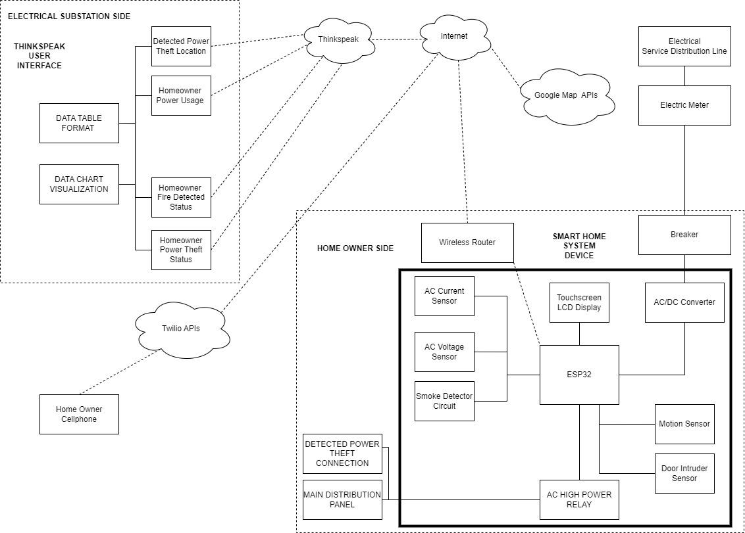

**3 Systems of the Study**

**Consumer Device side**

The primary function of the consumer device is to identify instances of power theft and unauthorized entry into a house. When such incidents occur, the consumer device can use its IoT connection to transmit the device's current location to the electrical substation, or it can send a text message (SMS) to the homeowner's cellphone. The consumer device is equipped with various sensors, including an AC current sensor, an AC voltage sensor, a smoke detector circuit, a motion sensor, and a door intruder sensor. The device utilizes the ESP32 microcontroller unit (MCU). Additionally, the consumer device features a touchscreen LCD display, which serves two purposes: displaying the sensor readings and functioning as a user interface for configuring the device's parameters.

**Cloud Services**

For this study, three cloud platforms and services are employed. ThingSpeak is utilized to streamline the process of gathering, storing, and analyzing data from IoT devices, making it a favored option among researchers and developers. By utilizing ThingSpeak, the researcher can transmit various parameters, including the location of detected power theft or burglary, homeowner power usage, homeowner thermostat readings, and fire detection, to the electrical substation side.

In addition, the researcher makes use of Twilio's programmable SMS functionality. Twilio offers APIs that enable developers to send and receive SMS messages programmatically. This feature serves a range of purposes such as sending notifications, alerts, verification codes, and facilitating customer communication.

To capture the current GPS coordinates of the consumer device and transmit them to the electrical substation side, the researcher incorporates the Google Maps APIs. Furthermore, the transmitted data to the monitoring or electrical substation side includes the Google Maps' Map Overlay URL for added context.

**Electrical Substation Side or Monitoring Side**

Using the ThingSpeak User Interface, individuals have the ability to establish channels that facilitate the organization and storage of sensor and consumer data derived from the consumer device. Each channel consists of multiple fields that serve as storage units for the data. Users have the option to transmit data to ThingSpeak channels either by utilizing APIs or directly posting the data to the designated channel URL. Additionally, ThingSpeak offers support for data logging, data visualization, and data analysis tools.

On the monitoring side, the operator can leverage the capabilities of ThingSpeak to visualize the transmitted parameters originating from each consumer device. These parameters encompass crucial information such as the device's location, homeowner power usage, homeowner thermistor reading, homeowner fire detection status, and homeowner power theft status.

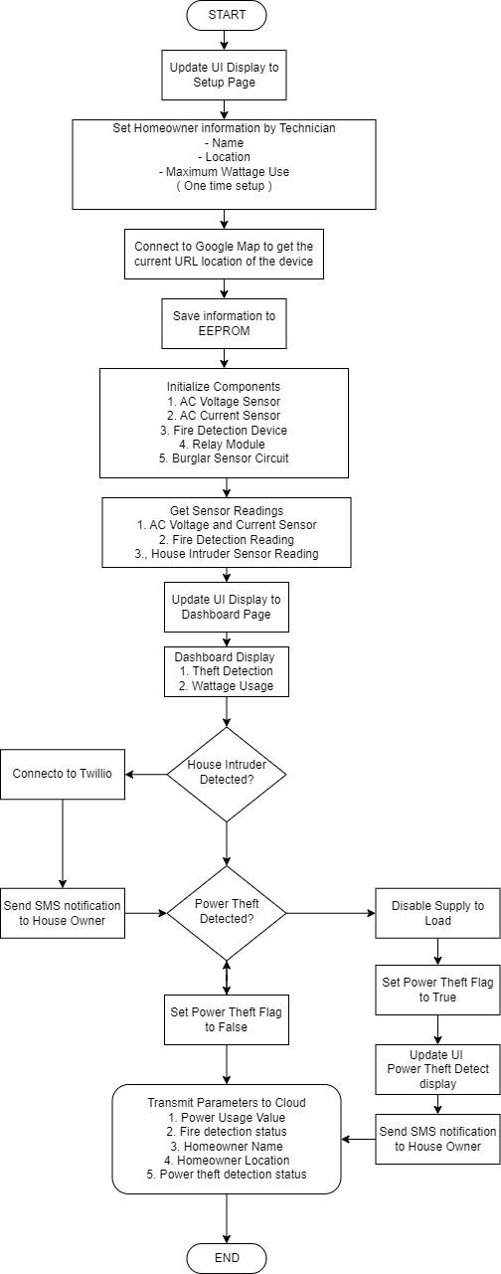

**Flowchart**

**Initialization**

When the device is operated for the first time, it enters a setup mode. During this setup, the technician is required to input homeowner information including name, location, and maximum wattage usage. Once these parameters are provided, the device establishes a connection with Google Maps to capture the URL representing its current location on the map. All the set parameters are then saved to the internal flash memory of the device.

Following the parameter configuration, the consumer device proceeds to initialize all the components connected to it. These components encompass various sensors such as temperature and humidity sensors, AC current and voltage sensors, a fire detection module, a relay module, and a burglar sensor circuit.

**Run time mode**

During the device's runtime mode, it continually monitors and captures sensor readings related to temperature, humidity, AC voltage, AC current, fire detection status, and house intruder status. The device then proceeds to display these parameters on a dashboard. Additionally, it transmits the collected parameters to the monitoring side of the system.

In the event that a house intruder is detected, the device utilizes Twilio's programmable SMS feature to promptly notify the homeowner. Similarly, if power theft is detected, both the homeowner and the electrical substation side are notified. The homeowner receives a notification via SMS, while the electrical substation side is informed through ThingSpeak.

Furthermore, upon detecting power theft, the device is capable of interrupting the power supply to the distribution line specifically associated with the detected theft.

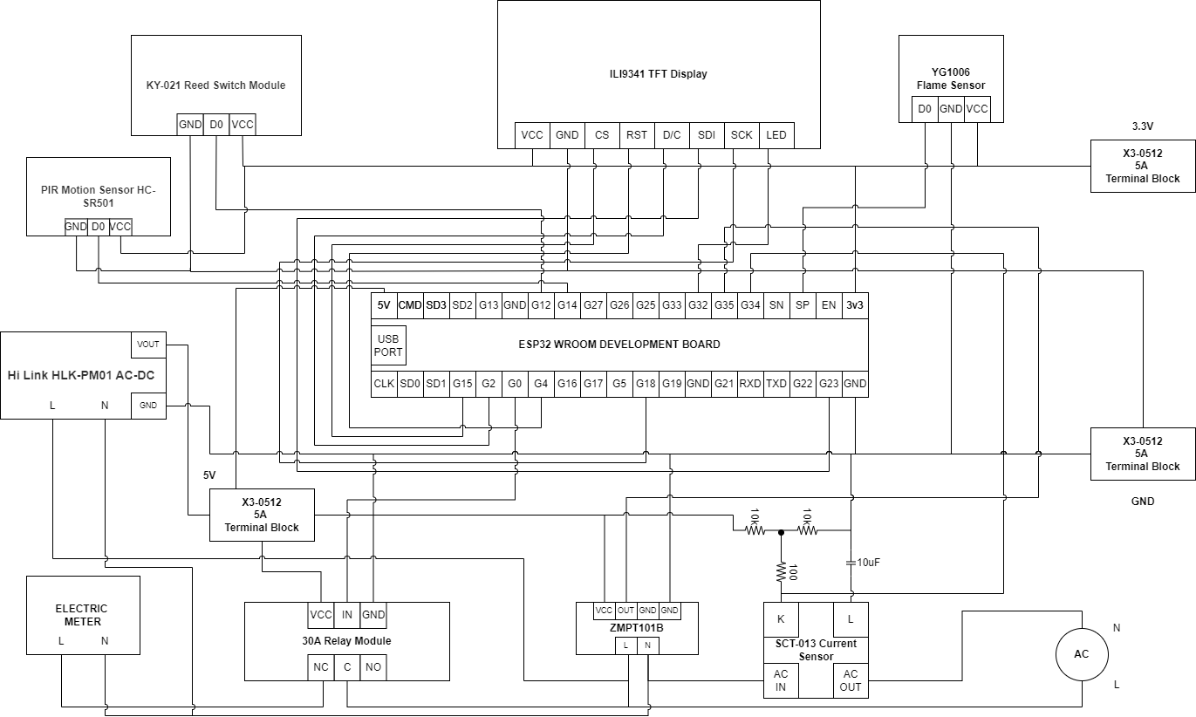

**WIRING DIAGRAM**

**MCU**

The figure above shows the wiring connection and components used for this project. The ESP32 is selected MCU for this project due to it’s connectivity feature while Arduino boards generally require additional modules (shields) to provide connectivity options like Wi-Fi or Bluetooth, ESP boards (ESP8266 and ESP32) come with built-in Wi-Fi and Bluetooth capabilities, making them more suitable for IoT applications. The other reason why ESP32 is selected because ESP boards (especially ESP32) typically have more processing power, memory, and I/O pins compared to most Arduino boards. This allows ESP boards to handle more complex tasks and support advanced features.

**SENSORS**

The sensors employed to monitor power theft consist of the ZMPT101B voltage sensor and the SCT-013 current sensor. These sensors are specifically designed to measure voltage and current, respectively.

To detect house intruders, the monitoring system incorporates the reed switch module and the PIR motion sensor HC-SR501. The reed switch module serves as a sensor for detecting door or window opening, while the PIR motion sensor detects movement within the monitored area.

For the additional feature of house monitoring, the YG1006 Flame sensor is employed to detect the presence of fire.

**User Interface**

The research project incorporates the use of the ILI9341 TFT Touchscreen display to present captured parameters in a dashboard format. This display facilitates the input of settings and parameters by both technicians and homeowners. The selection of the ILI9341 TFT display is based on its ability to deliver a visually superior experience characterized by high-quality visuals and vibrant colors. It exhibits excellent color reproduction, contrast, and clarity, rendering it well-suited for the display of images, graphics, and visually rich user interfaces. Additionally, the display's built-in touchscreen functionality enables direct user interaction through touch gestures, resulting in intuitive and user-friendly interactions. This makes it particularly suitable for applications that rely on touch-based input.

**Power Devices**

For the purpose of disconnecting the distribution line in the event of a detected power theft, the research project opted for a 30A relay module. This module is selected to ensure a reliable disconnection process. The input of the relay module is connected to the 220V AC main, while its output is connected to the distribution panel of the homeowner.

In addition, the device incorporates an AC-DC converter that transforms the 220V AC input to a 5V DC output, which is used to power the MCU (Microcontroller Unit). This converter is also connected to the electrical AC main to obtain the necessary power supply.

To facilitate the DC connections, the researcher utilizes terminal blocks specifically designed for the 5V, 3.3V, and ground connections. These terminal blocks provide a secure and convenient method for establishing the required DC connections within the system.

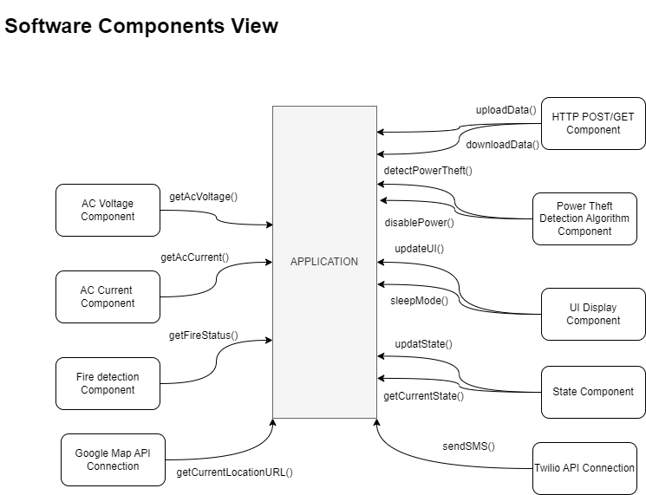

( **NOTE**: Reference Only for Developer not include in research project )

**Bill of Materials**

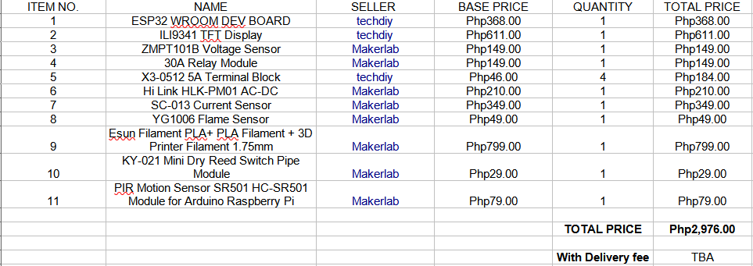

**(NOTE:** Updated bill of materials included two components for house intruder detection)